Specification sheet
PP CARTRIDGE FILTER HOUSING

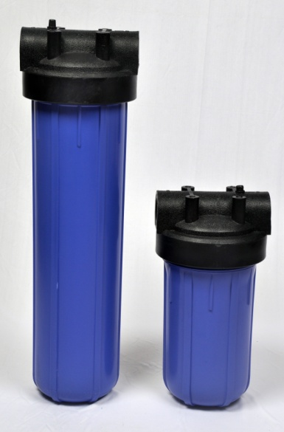
SS filters offer PP molded opaque and transparent filter housings that are made using polypropylene. These housings are known for its chemical resistance. The housing can accommodate single cartridge of lengths of 125, 250 or 500 mm. PP Filter housings come in two sizes- standard and jumbo filter housing-depending upon the OD of the filter cartridge. They can be used in place of costly stainless steel filter housings.

FEATURES & BENEFITS:

- Low pressure drop design
- High flow rates
- Positive sealing
- Easy to install as well as maintain
- Standard & big blue
- Excellent chemical compatibility

PRODUCT SPECIFICATIONS

MOC | Polypropylene  Bowl- Blue Reinforced material(Opaque) or clear (transparent)
Length of filter cartridge | 5”/ 10”/ 20”
Inlet/Outlet | ¾ “ to 1.5” BSP
O-ring Connections | Silicon, EPDM
Vent/Drain | Pressure relief Button
Maximum Operating Temperature | 50 C
Maximum Operating Pressure | 3.5 Bar
Housing color | Blue Bowl/ Black cap (Opaque)  Transparent bowl/ black cap (Transparent)
Configuration of cartridge | Double open end

APPLICATIONS:

- Process water
- Process fluids
- Reverse osmosis prefilter
- Beverages
- Plating solutions
- Fine chemicals, inks & dyes

