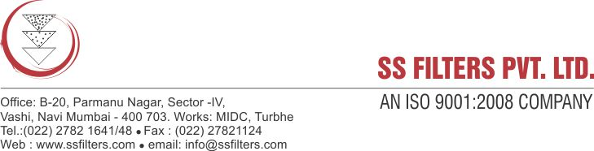

**Specification Sheet**

**SPUN FILTER CARTRIDGE (POLYPROPYLENE)**

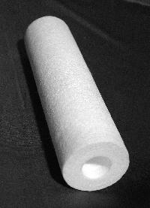**SS Filters** thermally bonded polypropylene spun filter cartridge utilize graded density media that is well suited for clarification & pre filtration applications where high particle removal is essential. The all-propylene construction provides excellent thermal & chemical compatibility with high & low pH chemicals. Also the graded density design efficiently captures contaminants throughout the media matrix resulting in excellent contaminant holding capacity, increased lifetime & low pressure drop.

In water applications, polypropylene media does not impart taste, odor or colors into the solution. For industrial applications, polypropylene offers superior chemical resistance and is not prone to bacterial attack. The thermal bonding process of the media eliminates the need for a core collapse. This process also greatly reduces fiber migration.

PP Spun Bonded Cartridges can be used either as a pre-filter or final filter for industrial, chemical process, pharmaceutical, food/beverage, cosmetics, water and other applications. PP Filter Cartridges are available in a wide range of lengths and micron sizes. Two sizes are available- standard and jumbo as per your flow rate and volume requirements.

**FEATURES & BENEFITS:**

* High flow rates and low pressure drops
* Wide chemical compatibility
* Particles removed through the entire depth of filter cartridge.
* Graded density structure for maximum dirt holding capacity
* Supported core for overall strength
* Thermal bonding process stops media migration
* Contains no resin binders, solvent ,wetting or antistatic agents

**PRODUCT SPECIFICATIONS**

|  |  |
| --- | --- |
| Micron Rating | 1, 5, 10, 20 µ |
| Length | 10", 20", 30", 40” |
| Inner Dia for standard size  Inner Dia for jumbo size | 28 mm  28 mm |
| Outer Dia  Outer Dia for jumbo size | 60-64 mm  100-110 mm |
| Max operating temperature | 80˚ C |
| Max Differential Pressure | 3-4 bar (50 psi) @ 21˚C |

**CONSTRUCTION:**

* Filter media: 100% Polypropylene fiber
* Support media: Polypropylene fiber
* Inner core: Polypropylene cage

**CONFIGURATION:**

* Double open end type (DOE Type)
* Code 7S (226 ‘O’ Ring design/ Bayonet or fin)

**APPLICATIONS:**

* Pharmaceutical Industry
* RO treatment of water
* Color & Dyes Industry
* Chemical Industry
* Water Treatment Industry
* Textile industry
* Edible oils
* Electronics
* Cosmetics