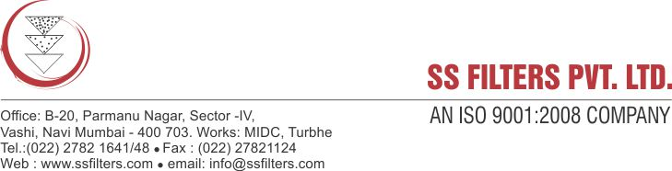

Specification sheet

STAINLESS STEEL SINGLE CARTRIDGE FILTER HOUSING

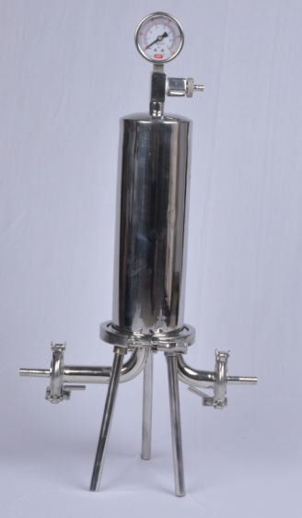

SS Filters stainless steel cartridge filter housings are designed for high purity applications. All wetted surfaces are constructed of SS 316 / SS 304 and are mirror polished, providing excellent corrosion resistance. The housing comes in 10" to 40"cartridge sizes to meet the needs of your application. The housing can support both Double Open End (DOE) and Code-7 type cartridges. The design of the housing provides for positive seal with the filters thereby preventing fluid by pass.

FEATURES & BENEFITS:

- Stainless steel construction provides excellent corrosion protection for rugged, long-lasting service.
- Housing drain allows full drainage of chambers for optimized filter change out.
- Provision for air venting before start-up for more efficient filter operation.
- Allows for use of both DOE or SOE cartridges
- Mirror polish finish eliminates possible contamination which could leach into the process chemicals.

PRODUCT SPECIFICATIONS

MOC | SS304/ SS316/ SS316 L
Shell dia | 100 mm
Length of cartridge | 10", 20", 30", 40"
Inlet/ Outlet | 1/2" , 1", 1.5" BSP  Triclover/ Flange/ coupling
Vent/Drain | 1/4" BSP
Finish | Mirror polish
O-ring | Silicon/ EPDM/ Viton
Maximum Operating  Pressure | 10 Bar at 121°C

APPLICATIONS:

- Chemicals & Petrochemicals: Solvents, solutions, chemical filtration, acids, bases
- Food & Beverage: bottled water, beers, wines, flavors, polishing, clarification
- Health Care & Pharmaceuticals: Membrane filtration, ophthalmic, oral medicines, serum
- Industrial processes: clean water, removal of carbon
- Paints & Coatings: paints, coatings
- Industrial water treatment
- Electronics: High purity water, photo resists
- Cosmetics: Alcohols, creams, lotions, essential oils, mouthwashes

SS filter housings can also be modified to meet your specific process requirements. Please contact customer service if a custom housing is needed.

